**Overview of the Variational Quantum Eigensolver (VQE)**

| *Steven Lam*  *Department of Computer Science,*  *California State, Chico*  *slam@csuchico.edu* | *Miles E. Benton*  *Department of Computer Science*  *California State, Chico*  *mebenton@csuchico.edu* | *Kevin C. Douglass*  *Department of Computer Science*  *California State, Chico*  *kcdouglass@csuchico.edu* |
| --- | --- | --- |

**Abstract**

*The Variational Quantum Eigensolver (VQE) is a powerful algorithm that is said to have one of the most promising applications for quantum computing. The VQE gives scientists and researchers the ability to solve complex problems that are too difficult for classical computers to handle and is central to the field of quantum chemistry which has been constrained by current computational limits to model intricate wave functions. This paper delves into the use of the VQE algorithm to measure the ground state energy of a molecule which is the lowest possible energy state that a molecule can occupy. This is accomplished using a quantum computer to represent electrons in a molecule as qubits, which are the basic building blocks of quantum computers.*

*Prior to the development of the Variational Quantum Eigensolver (VQE), solving complex quantum chemistry problems was computationally intractable for classical computers. Existing algorithms required significantly more qubits than VQE, making them infeasable for today’s quamtum computers. Classical methods, like the Hartree-Fock approach, were limited in their accuracy, particularly for molecules with strong electron correlation [2]. This meant that researchers were unable to accurately predict the electronic structure and chemical properties of many important molecules. VQE aims to solve this problem by using a hybrid classical-quantum approach. As such, its ability to solve problems with a level of precision classical computers are unable to make is a valuable tool in quantum chemistry, and has the potential to provide more accurate results for complex molecules [5].*

*This hybrid approach allows for problems that are beyond the capabilities of classical computers to be solved, making it a valuable tool in quantum chemistry. For instance, in order to calculate the overall energy of the molecule, a trial wavefunction is used to find the ground state energy of the molecule by repeatedly removing electron residuals, optimizing itself. The algorithm combines classical and quantum computing to solve the problem, with the quantum computer performing the calculations that are intractable on classical computers. [3]*

**1. Introduction**

**1.1. Background**

A key concept in VQE is the Hamiltonian, which represents the overall energy of the molecule. The Hamiltonian is a mathematical operator that describes the total energy of the system, including the kinetic and potential energy of the electrons in the molecule. By representing the Hamiltonian as a set of qubits, the energy of a molecule can be calculated by measuring the state of the qubits. The algorithm optimizes a trial wavefunction to find the ground state energy of the molecule, which provides valuable insights into the electronic structure and chemical properties of the molecule. [2]

In contrast, Hartree-Fock is a classical method used to approximate the electronic structure of molecules. The Hartree Fock method uses a set of mathematical equations to calculate the electronic energy of a molecule, taking into account the electron-electron repulsion and the electron-nucleus attraction. This approach is limited in its accuracy, particularly for molecules with large amounts of electrons. However, it remains a useful method for quickly estimating electronic energies and properties of relatively simple molecules. In comparison, hybrid classical-quantum approach has the potential to provide more accurate results for more complex molecules. [4]

Below is an example, comparing the VQE algorithm computing the ground state energy for a Lithium (Li) and Hydrogen (H) bond. Figure 1 to see the minimum ground state energy, or hamiltonian, that they require. As we can see, the algorithm retrieves noticeably more accurate results the farther apart the molecules get from each other. [3]



**1.2. Origins of the Algorithm**

The idea of using variational methods to solve quantum mechanical problems had been around for several decades prior to its development.[citation needed] In fact, a paper published in 2013 by Alberto Peruzzo, Alán Aspuru-Guzik, and Jeremy O'Brien proposed a quantum variational eigensolver for solving the electronic structure problem. This paper laid the groundwork for the development of VQE in 2014. The algorithm was first proposed by researchers at Harvard University and MIT, including Ryan Babbush, Craig Gidney, Nathan Wiebe, and Alán Aspuru-Guzik. However, the underlying concept of using variational methods to solve quantum mechanical problems was not new, and had been explored in the literature prior to the development of VQE. [6]

**1.3. Changes Since its Proposal**

Since the initial proposal of the algorithm in 2014, there have been numerous advancements and adaptations. One significant development is the integration of error mitigation techniques, which aim to minimize the influence of noise and errors in quantum computing hardware. These techniques enhance the algorithm's robustness and ability to produce accurate results. Another improvement is the creation of novel optimization algorithms that can more efficiently determine the ground state energy of a molecule. By optimizing the trial wavefunction more effectively, these algorithms can yield better results in less time. [5]

**1.4. Modern Day Applications**

In modern-day research, VQE could be used to solve a variety of problems in quantum chemistry and materials science. It has the potential to be used to calculate the electronic structure of molecules, predict the properties of materials, and simulate chemical reactions. The algorithm also could be used in drug discovery and to optimize chemical processes. As quantum computing technology continues to advance, VQE is expected to play a critical role in solving increasingly complex problems in chemistry [3].

**2. Components**

In the context of the Variational Quantum Eigensolver (VQE) algorithm, electrons in molecules are represented as qubits using the Jordan-Wigner Representation or the spin-orbital transformation. These qubits are used to construct a parameterized quantum circuit called an ansatz gate, which is used to prepare a trial state that approximates the ground state of the molecule. The parameters of the ansatz gate are optimized to minimize the energy expectation value of a Hamiltonian operator that represents the electronic structure of the molecule. To efficiently explore the solution space, the wavefunction of the system is represented using Pauli strings, which are sets of Pauli functions in Pauli matrices. By evaluating the energy expectation value of the Hamiltonian for different trial states, we can estimate the ground state energy of the molecule. The use of qubits, Ansatz gates, and Pauli strings in VQE will allow us to solve problems in quantum chemistry that are beyond the reach of classical computers, offering new opportunities for computational modeling and materials discovery.

**2.1 Hamiltonian**

The Hamiltonian represents the ground state energy of a molecule. The VQE algorithm utilizes the Hamiltonian to optimize the parameters of the ansatz gate, aiming to minimize the ground state energy value. This is done by preparing different trial states, which approximate the ground state of the molecule, and evaluating their energy expectation values.

In this context, electrons in molecules are represented as qubits using the Jordan-Wigner Representation or the spin-orbital transformation.

By optimizing the ansatz gate parameters and evaluating the energy expectation value of the Hamiltonian for different trial states, the VQE algorithm allows us to estimate the ground state energy of the molecule.

**2.2. Electrons**

In quantum computing, electrons in molecules can be represented using qubits. Specifically, the Jordan-Wigner Representation is used to represent each electron in a molecule as a qubit. This representation takes advantage of the fact that each orbital in a molecule can only have two electrons, one with spin up and one with spin down. Thus, each orbital can be thought of as having two "slots", with each slot representing either a 1, where an electron is present, or a 0, which means no electron is present,.

In the Jordan-Wigner Representation, one qubit is used per slot, which means that one qubit is used to represent each electron. For instance, if we had a molecule with two orbitals and one electron in each orbital, we would have the qubit representation |1010>. If we had four electrons, with two in each slot, we would have |1111>. Using this notation, we can represent the ground state of the molecule's electron energy levels.

In addition to the Jordan-Wigner Representation, rotations can also be used to transform the electrons in a molecule into qubits. This is done by applying a unitary transformation to the molecule's electronic structure that maps the electronic wavefunction onto the qubit state. This is known as the spin-orbital transformation, which rotates the spin and spatial coordinates of each electron into qubit states.

**2.3. Ansatz Gates**

An Ansatz gate is a parameterized quantum circuit used to prepare a quantum state for further processing. It is essentially a sequence of quantum gates with adjustable parameters that can be tuned to produce different quantum states. The idea behind an Ansatz gate is to use a simple, easily parameterized circuit to approximate the complex quantum state that we are interested in. By adjusting the parameters of the Ansatz gate, we can get closer and closer to the actual quantum state we want to prepare.

Ansatz gates are particularly useful in the field of quantum chemistry, where they are used in conjunction with the algorithm to calculate the ground state energy of a molecule. In VQE, we start by representing the electronic structure of the molecule as a Hamiltonian operator. This operator contains terms that describe the energy of the electrons in different orbitals and the interactions between them.

We then use an Ansatz gate to prepare a trial state that we hope will approximate the true ground state of the molecule. The parameters of the Ansatz gate are adjusted to minimize the expectation value of the Hamiltonian operator for this trial state. This expectation value gives us an estimate of the ground state energy of the molecule.

**2.4. Pauli Strings**

Pauli strings are a set of mathematical functions that can be used to represent the wavefunction of a quantum system. In VQE, these functions are chosen to be Pauli in the Pauli matrices, which are a set of matrices that can be used to represent the spin of a particle in quantum mechanics. Each Pauli string is constructed by multiplying together a set of Pauli matrices and coefficients, with each term representing a different operator acting on the qubits in the circuit.

The advantage of using Pauli strings as a basis set is that they can be efficiently evaluated on a quantum computer using a small number of gates. This is because each term in the Pauli string can be implemented using a simple circuit consisting of a few gates, and the Pauli can be evaluated by applying these circuits in sequence. Moreover, since the number of terms in the Pauli strings can be adjusted, Pauli strings can provide a flexible and scalable basis set that can be used to approximate the ground state of a wide range of quantum systems.

Compared to ansatz gates, Pauli strings offer a different approach to constructing a quantum circuit for VQE. While ansatz gates are used to construct a parameterized circuit that is optimized to minimize the energy expectation value, Pauli strings are used as a basis set to represent the wavefunction of the system. In other words, ansatz gates are used to construct the circuit, while Pauli strings are used to define the form of the wavefunction that is optimized. Both approaches have their advantages and limitations, and the choice of which method to use often depends on the specific problem being solved and the resources available.

**3.1. Implementation of the Algorithm**

We implemented the algorithm using code provided by QisKit code is section 4. It generates an initial Ansatz gate based on the Hartree-Fock algorithm. Then, inside a for loop, it runs the VQE for each distance interval we set in order to find the grond state energy. Then, it takes the resulting energies, and plots them on a graph along with the result from the classical algorithm as a reference for comparison to see the efficiency of the VQE. .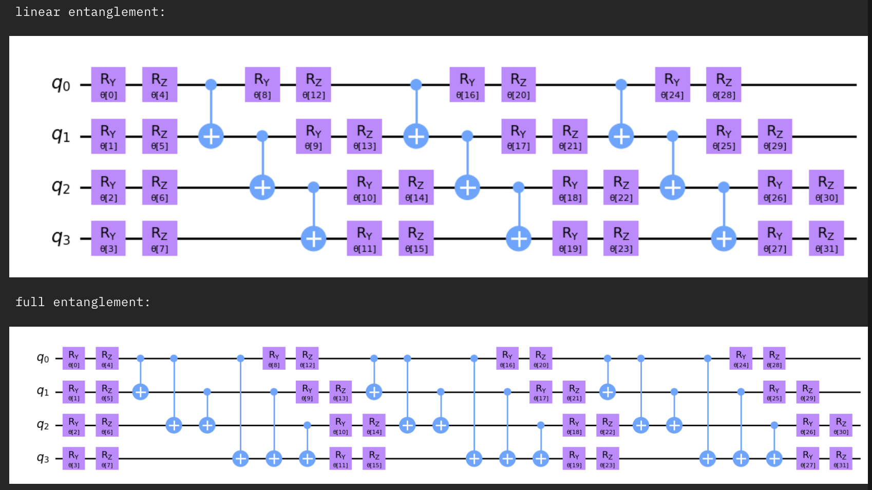

Figure 3.1: A graphical representation of the Ansatz gate generated by the QisKit code. The 4 qubits for circuit diagrams represent the molecular construct of Hydrogen and Lithium due to the fact that Hydrogen has 1-electron and Lithium has 3.

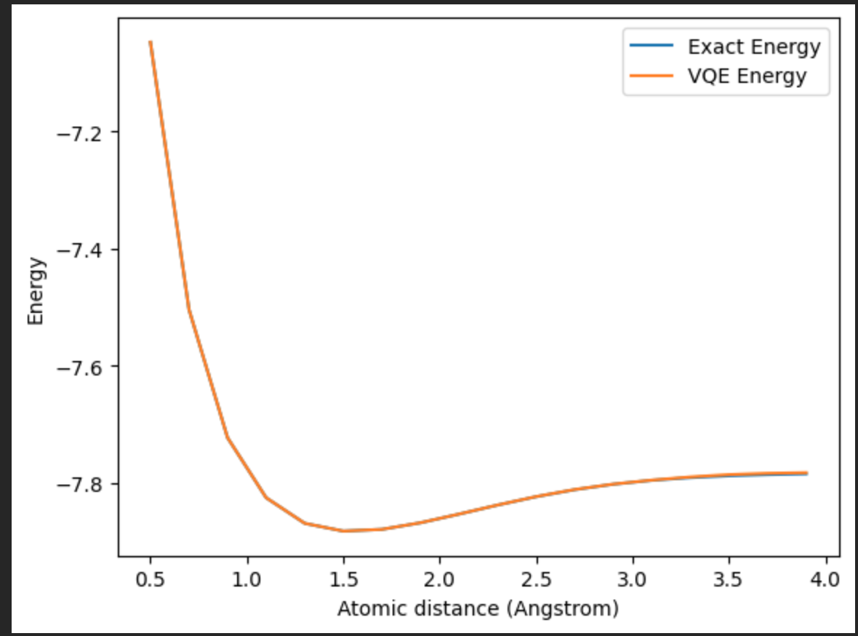

Figure 3.2: A graph of the ground-state energjes of the two molecules with respect to distance. The distances between the exact energy and the VQE energy is roughly one-tenth of a percent difference. This is a vast improvement to the Hartree-Fock implementation in figure 1.1, which had noticeable difference between the exact energy and the output of Hartree-Fock.

**3.2. Analysis of the Algorithm**

As we can clearly see in Figure 1.1, the VQE was able to accurately estimate the ground state energy of the Lithium and Hydrogen molecules at any distance. In comparison, the Hartree-Fock method becomes less accurate the further the distance between the two molecules. The classical algorithm is being used as a baseline in the graph, however it is less asymptotically efficient than the VQE.

The runtime of the VQE is linear with respect to the number of gates, which increases linearly with the number of qubits. Additionally, it depends on the convergence time of the optimization loop.

For example, in the code provided in section 4, there is a for loop where VQE is executed. This for loop calculates the initial ground state energy once, and then uses the ground state energy returned for each VQE called at each distance to optimize the next ground state energy variable and function call. This approach saves computational time because the exact ground state energy is typically computationally expensive to calculate. By computing it only once and reusing the result for all iterations of the loop, the code avoids redundant calculations and significantly reduces the overall run time.

As a result of this, it is difficult to quantify the exact asymptotic complexity of the algorithm, as it is depends heavily on the exact problem you are dealing with. However, convergence tends to happen fairly quickly on practice, yielding significantly improved performance over classical algorithms.

In comparison, a common classical algorithm would scale cubically with respect to the dimensionality of the hamiltonian matrix, yielding a running time of O(n^3).

**4. Qiskit Code**

The implementation of VQE used for this paper can be found at the following address: <https://gist.github.com/Slam210/9ab96ad8cdfb7fc884f6503b4299f1f2>

**5. Conclusion**

The Variational Quantum Eigensolver (VQE) is one of the most promising upcoming applications of quantum computing. By representing electrons as qubits, it is able to harness the fundamental nature of quantum computers in order to more efficiently simulate the interactions between molecules. However, it is limited by the the fact that you need one qubit per electron in the molecules you want to represent. Current quantum computers only have on the order of hundreds of qubits, limiting the real-world applications of the algorithm.

Despite these limitations, it is important to note that we are still in the early stages of quantum computing. The number of qubits in quantum computers has been steadily increasing over the years, and advancements in quantum error correction and quantum algorithms may allow us to use these qubits more efficiently in the future. While the requirement of one qubit per electron poses a challenge for VQE's real-world applications today, ongoing research and technological improvements hold the promise to overcome these limitations, unlocking the full potential of the Variational Quantum Eigensolver and quantum computing as a whole.

**References**

[1] Delgado, Alain. “A brief overview of VQE — PennyLane documentation.” Pennylane, 8 February 2020, https://pennylane.ai/qml/demos/tutorial_vqe.html. Accessed 28 April 2023.

[2] Hatcher, Eli. “Variational Quantum Eigensolvers.” Medium, 8 November 2022, https://medium.com/@eli.hatcher/variational-quantum-eigensolvers-68f2afc45d3c. Accessed 20 April 2023.

[3] McArdle, Sam, et al. ‘Quantum Computational Chemistry’. Reviews of Modern Physics, vol. 92, no. 1, American Physical Society, Mar. 2020, p. 015003, https://doi.org10.1103/RevModPhys.92.015003. Accessed 20 April 2023.

[4] Qiskit. “The Variational Quantum Eigensolver — Programming on Quantum Computers — Coding with Qiskit S2E4.” YouTube, Qiskit, 6 November 2020, https://www.youtube.com/watch?v=Z-A6G0WVI9w. Accessed 14 April 2023.

[5] Tillya, Jules, et al. “The Variational Quantum Eigensolver: a review of methods and best practices.” arXiv, 9 November 2021, https://arxiv.org/abs/2111.05176. Accessed 18 April 2023.

[6] “Variational quantum eigensolver.” Wikipedia, https://en.wikipedia.org/wiki/Variational_quantum_eigensolver. Accessed 20 April 2023